**Министерство цифрового развития, связи и массовых коммуникаций Российской Федерации**

Ордена Трудового Красного Знамени федеральное государственное бюджетное образовательное учреждение высшего образования

**Московский технический университет связи и информатики**

Кафедра «Информатики»

**ЛАБОРАТОРНАЯ РАБОТА №8**

**по дисциплине ВвИТ**

«Бот UI»

Выполнил студент группы БИН2003 Мельникова Ю.В.

Проверил: Аршинов Е. А.

Москва 2021

**1. Цель работы:**

Создать свое приложение, которое будет выводит актуальное расписание с преподавателями.

**2. Выполнение работы:**

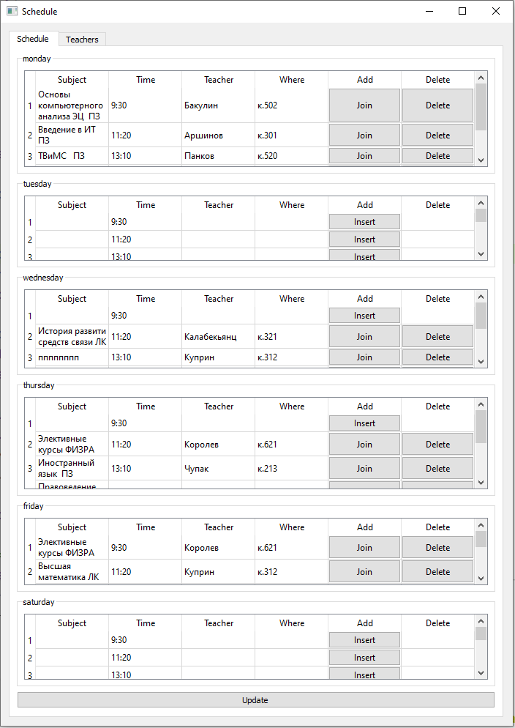

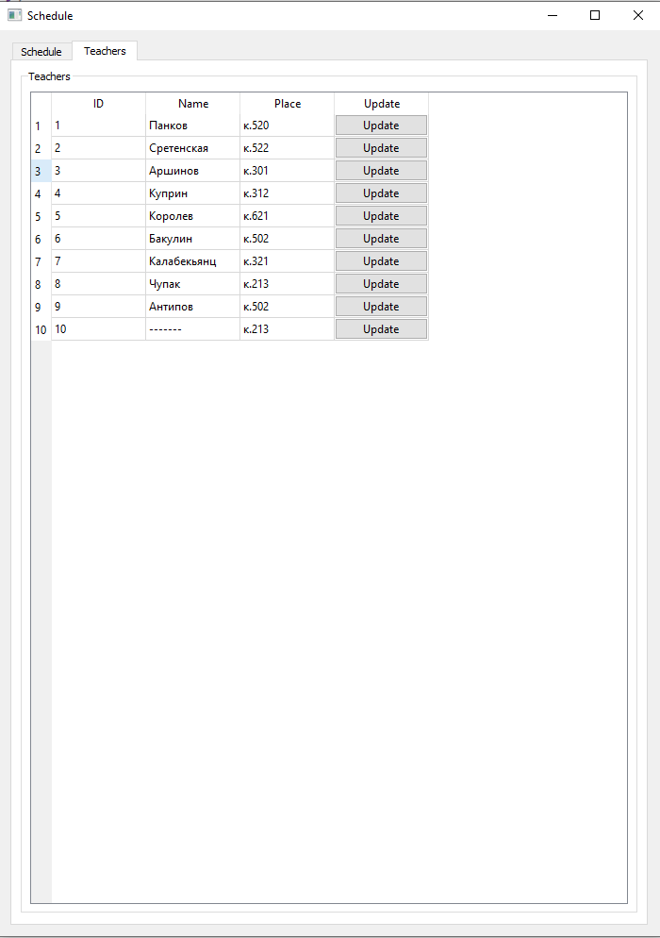

**Код:**

import psycopg2

import sys

from datetime import date

from PyQt5.QtWidgets import (QApplication, QWidget,

QTabWidget, QAbstractScrollArea,

QVBoxLayout, QHBoxLayout,

QTableWidget, QGroupBox,

QTableWidgetItem, QPushButton, QMessageBox)

from config import DATABASE, USER, PASSWORD

time = ['9:30', '11:20', '13:10', '15:25', '17:15', '19:00', '20:40', '22:10']

days = ['monday', 'tuesday', 'wednesday', 'thursday', 'friday', 'saturday']

class MainWindow(QWidget):

def __init__(self):

super(MainWindow, self).__init__()

self.week_type = 'чет' if get_week_num() % 2 == 0 else 'неч'

self._connect_to_db()

self.setWindowTitle("Schedule")

self.vbox = QVBoxLayout(self)

self.tabs = QTabWidget(self)

self.vbox.addWidget(self.tabs)

self._create_shedule_tab()

self._create_teachers_tab()

def _connect_to_db(self):

self.conn = psycopg2.connect(database=DATABASE,

user=USER,

password=PASSWORD,

host="localhost",

port="5432")

self.cursor = self.conn.cursor()

self.timetable_table_name = 'qtimetable'

self.teachers_table_name = 'teachers'

self.teachers_names, self.teachers_places = self._fetch_teachers() self.class_names = self._fetch_classes()

def _fetch_teachers(self):

select_teachers = f"SELECT id, name FROM {self.teachers_table_name}"

self.cursor.execute(select_teachers)

names = dict(self.cursor.fetchall())

select_teachers = f"SELECT id, place FROM {self.teachers_table_name}"

self.cursor.execute(select_teachers)

places = dict(self.cursor.fetchall())

return [names, places]

def _fetch_classes(self):

select_classes = f"SELECT * FROM {self.timetable_table_name}"

self.cursor.execute(select_classes)

return [class_name[1] for class_name in (self.cursor.fetchall())]

def _create_teachers_table(self, gbox):

table = QTableWidget()

table.setSizeAdjustPolicy(QAbstractScrollArea.AdjustToContents)

table.setColumnCount(5)

table.setHorizontalHeaderLabels(["ID", "Name", "Place", "Update", "Delete"])

table.setRowCount(len(self.teachers_names) + 1)

for i in range(len(self.teachers_names)):

joinButton = QPushButton("Update")

joinButton.clicked.connect(lambda ch, tbl=table, id=(i + 1):self._change_teacher_from_table(tbl, id))

deleteButton = QPushButton("Delete")

deleteButton.clicked.connect(lambda ch, t_id=(i + 1):self._delete_teacher(t_id))

table.setItem(i, 0, QTableWidgetItem(str(i + 1)))

try:

table.setItem(i, 1, QTableWidgetItem(str(self.teachers_names[i + 1])))

table.setItem(i, 2, QTableWidgetItem(str(self.teachers_places[i + 1])))

except KeyError:

table.setItem(i, 1, QTableWidgetItem())

table.setItem(i, 2, QTableWidgetItem())

table.setCellWidget(i, 3, joinButton)

table.setCellWidget(i, 4, deleteButton)

joinButton = QPushButton("Update")

joinButton.clicked.connect(lambda ch, tbl=table:self._insert_teacher(tbl.item(i + 1, 1).text(), tbl.item(i + 1, 2).text()))

table.setItem(i + 1, 0, QTableWidgetItem(''))

table.setItem(i + 1, 1, QTableWidgetItem(''))

table.setItem(i + 1, 2, QTableWidgetItem(''))

table.setCellWidget(i + 1, 3, joinButton)

table.resizeRowsToContents()

mvbox = QVBoxLayout()

mvbox.addWidget(table)

gbox.setLayout(mvbox)

def _create_teachers_tab(self):

self.teachers_tab = QWidget()

self.tabs.addTab(self.teachers_tab, "Teachers")

gbox = QGroupBox('Teachers')

svbox = QVBoxLayout()

shboxes = [QHBoxLayout() for _ in range(2)]

[svbox.addLayout(shbox) for shbox in shboxes]

shboxes[0].addWidget(gbox)

self._create_teachers_table(gbox)

self.teachers_tab.setLayout(svbox)

update_shedule_button = QPushButton("Update")

shboxes[1].addWidget(update_shedule_button)

update_shedule_button.clicked.connect(lambda : self._update_shedule())

self.teachers_tab.setLayout(svbox)

def _create_table(self, table, gbox, weekday):

table = QTableWidget()

table.setSizeAdjustPolicy(QAbstractScrollArea.AdjustToContents)

table.setColumnCount(6)

table.setHorizontalHeaderLabels(["Subject", "Time", "Teacher", "Where", "Add", "Delete"])

self._update_table(table, weekday)

mvbox = QVBoxLayout()

mvbox.addWidget(table)

gbox.setLayout(mvbox)

def _create_shedule_tab(self):

self.shedule_tab = QWidget()

self.tabs.addTab(self.shedule_tab, "Schedule")

self.gboxes = [QGroupBox(day) for day in days]

self.svbox = QVBoxLayout()

self.shboxes = [QVBoxLayout() for _ in range(2)]

[self.svbox.addLayout(shbox) for shbox in self.shboxes]

[self.shboxes[0].addWidget(day_box) for day_box in self.gboxes]

self.tables = [QTableWidget() for _ in range(6)]

for i, table in enumerate(self.tables):

self._create_table(table, self.gboxes[i], i)

self.update_shedule_button = QPushButton("Update")

self.shboxes[1].addWidget(self.update_shedule_button)

self.update_shedule_button.clicked.connect(lambda : self._update_shedule())

self.shedule_tab.setLayout(self.svbox)

def _update_table(self, table, weekday):

global time

what_we_need = f"WHERE weekday = {weekday} AND week = '{self.week_type}';"

select_day = f"SELECT * FROM {self.timetable_table_name} {what_we_need}"

self.cursor.execute(select_day)

records = sorted(list(self.cursor.fetchall()), key=lambda elem: elem[4])

table.setRowCount(len(records) + 1)

empty = ['None', 'удалена', '', 'тут могла быть ваша пара']

for i, r in enumerate(records):

if str(r[1]) not in empty:

joinButton = QPushButton("Join")

deleteButton = QPushButton("Delete")

joinButton.clicked.connect(lambda ch, wd=weekday, tbl=table, class_num=i:self._change_day_from_table(tbl, wd, class_num))

deleteButton.clicked.connect(lambda ch, tbl=table, wd=weekday, num = r[4]:self._delete_class(wd, num))

table.setItem(i, 0, QTableWidgetItem(str(r[1])))

table.setItem(i, 1, QTableWidgetItem(str(time[i])))

try:

table.setItem(i, 2, QTableWidgetItem(str(self.teachers_names[r[5]])))

table.setItem(i, 3, QTableWidgetItem(str(self.teachers_places[r[5]])))

except KeyError:

table.setItem(i, 2, QTableWidgetItem(str(self.teachers_names[10])))

table.setItem(i, 3, QTableWidgetItem((self.teachers_places[10])))

table.setCellWidget(i, 4, joinButton)

table.setCellWidget(i, 5, deleteButton)

else:

table.setItem(i, 0, QTableWidgetItem(''))

table.setItem(i, 1, QTableWidgetItem(str(time[i])))

insert_button = QPushButton("Insert")

insert_button.clicked.connect(lambda ch, tbl=table, wd=weekday, num=i:self._change_day_from_table(tbl, wd, num))

table.setCellWidget(i, 4, insert_button)

insert_button = QPushButton("Insert")

insert_button.clicked.connect(lambda ch, tbl=table:self._insert_class(tbl.item(i + 1, 0).text(), weekday, i + 1, tbl.item(i + 1, 0).text()))

table.setItem(i + 1, 0, QTableWidgetItem(''))

table.setItem(i + 1, 1, QTableWidgetItem(str(time[i + 1])))

table.setCellWidget(i + 1, 4, insert_button)

table.resizeRowsToContents()

def _change_day_from_table(self, table, weekday, class_num):

try:

text = table.item(class_num, 0).text()

try:

pr_id = int(table.item(class_num, 2).text())

if pr_id > len(self.teachers_names):

return QMessageBox.about(self, "Error", "Такого id не существует")

except:

return QMessageBox.about(self, "Error", "Введите ID цифрами")

update_day = f"UPDATE {self.timetable_table_name} SET class_name = %s, pr_id = %s WHERE weekday = %s AND class_num = %s AND week = '{self.week_type}'"

self.cursor.execute(update_day, (text, pr_id, weekday, class_num))

self.conn.commit()

except:

QMessageBox.about(self, "Error", "sql error")

def _change_teacher_from_table(self, table, id):

try:

update_teacher = f"UPDATE {self.teachers_table_name} SET name = %s WHERE id = %s"

self.cursor.execute(update_teacher, (str(table.item(id - 1, 1).text()), str(id), ))

update_teacher = f"UPDATE {self.teachers_table_name} SET place = %s WHERE id = %s"

self.cursor.execute(update_teacher, (str(table.item(id - 1, 2).text()), str(id), ))

self.conn.commit()

except:

QMessageBox.about(self, "Error", "Enter all fields")

def _insert_class(self, class_name, weekday, class_num, pr_id):

try:

insert_data = f"""

INSERT INTO {self.timetable_table_name} (class_name, week, weekday, class_num, pr_id)

VALUES (%s, %s, %s, %s, %s);

"""

self.cursor.execute(insert_data, (class_name, self.week_type, str(weekday), str(class_num), str(pr_id), ))

self.conn.commit()

self._update_shedule()

except:

QMessageBox.about(self, "Error", "sql error")

def _insert_teacher(self, name, place):

insert_data = f"""

INSERT INTO {self.teachers_table_name} (name, place)

VALUES (%s, %s);

"""

self.cursor.execute(insert_data, (name, place, ))

self.conn.commit()

self._update_shedule()

def _delete_class(self, weekday, class_num):

update_day = f"UPDATE {self.timetable_table_name} SET class_name = %s WHERE weekday = %s AND class_num = %s AND week = '{self.week_type}'"

self.cursor.execute(update_day, ('', weekday, class_num))

self.conn.commit()

self._update_shedule()

def _delete_teacher(self, teacher_id):

delete_day = f"DELETE FROM {self.teachers_table_name} WHERE id = %s;"

self.cursor.execute(delete_day, (str(teacher_id), ))

self.conn.commit()

self._update_shedule()

def _update_shedule(self):

self.teachers_names, self.teachers_places = self._fetch_teachers()

self.class_names = self._fetch_classes()

self.tabs.removeTab(1)

self.tabs.removeTab(0)

self._create_shedule_tab()

self._create_teachers_tab()

def get_week_num():

first_day = date(2021, 8, 30)

today = date.today()

delta = (today - first_day).days

week_number = (delta // 7) + 1

return week_number

app = QApplication(sys.argv)

win = MainWindow()

win.show()

sys.exit(app.exec_())